Міністерство освіти і науки України

Національний технічний університет України

«Київський Політехнічний Інститут»

Факультет прикладної математики

Кафедра «Спеціалізованих комп’ютерних систем»

Лабораторна робота №4

З дисципліни «Комп’ютерна схемотехніка»

Виконав:

студент групи КВ-92

Степанюк Михайло Федорович

Перевірив:

_____________________

Київ-2011

I.Декрементний лічильник з послідовним переносом на JK тригерах з природнім порядком лічби та модулем 16.

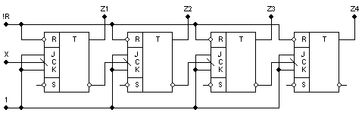

II.Інкрементний лічильник з наскрізним переносом на T тригерах з природнім порядком лічби та модулем 16.

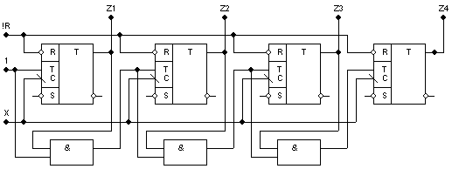

III. Реверсивний лічильник з паралельним переносом на T тригерах з природнім порядком лічби та модулем 16.

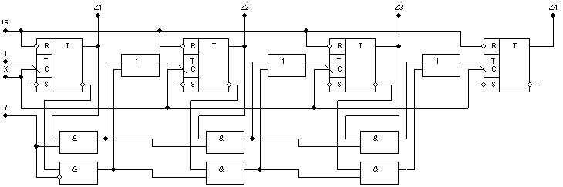

IV.Лічильник на RS тригерахз заданим порядком лічби.

|  |  |  |  |  |
| --- | --- | --- | --- | --- |
| Сигнал | Стан | | | |
| Q4 | Q3 | Q2 | Q1 |
| 0 | 0 | 0 | 0 | 1 |
| 1 | 0 | 0 | 1 | 0 |
| 2 | 0 | 0 | 1 | 1 |
| 3 | 0 | 1 | 0 | 1 |
| 4 | 0 | 1 | 1 | 0 |
| 5 | 1 | 0 | 0 | 0 |
| 6 | 1 | 0 | 1 | 0 |
| 7 | 1 | 0 | 1 | 1 |
| 8 | 1 | 1 | 0 | 0 |
| 9 | 1 | 1 | 1 | 0 |

|  |  |  |  |  |  |  |  |  |  |  |  |  |  |  |  |
| --- | --- | --- | --- | --- | --- | --- | --- | --- | --- | --- | --- | --- | --- | --- | --- |
| Стан (t) | | | | Стан (t + 1) | | | | Функції збудження  тригерів | | | | | | | |
| Q4 | Q3 | Q2 | Q1 | Q4 | Q3 | Q2 | Q1 | R4 | S4 | R3 | S3 | R2 | S2 | R1 | S1 |
| 0 | 0 | 0 | 1 | 0 | 0 | 1 | 0 | * | 0 | * | 0 | 0 | 1 | 1 | 0 |
| 0 | 0 | 1 | 0 | 0 | 0 | 1 | 1 | * | 0 | * | 0 | 0 | * | 0 | 1 |
| 0 | 0 | 1 | 1 | 0 | 1 | 0 | 1 | * | 0 | 0 | 1 | 1 | 0 | 0 | * |
| 0 | 1 | 0 | 1 | 0 | 1 | 1 | 0 | * | 0 | 0 | * | 0 | 1 | 1 | 0 |
| 0 | 1 | 1 | 0 | 1 | 0 | 0 | 0 | 0 | 1 | 1 | 0 | 1 | 0 | * | 0 |
| 1 | 0 | 0 | 0 | 1 | 0 | 1 | 0 | 0 | * | * | 0 | 0 | 1 | * | 0 |
| 1 | 0 | 1 | 0 | 1 | 0 | 1 | 1 | 0 | * | * | 0 | 0 | * | 0 | 1 |
| 1 | 0 | 1 | 1 | 1 | 1 | 0 | 0 | 0 | * | 0 | 1 | 1 | 0 | 1 | 0 |
| 1 | 1 | 0 | 0 | 1 | 1 | 1 | 0 | 0 | * | 0 | * | 0 | 1 | * | 0 |
| 1 | 1 | 1 | 0 | 0 | 0 | 0 | 1 | 1 | 0 | 1 | 0 | 1 | 0 | 0 | 1 |

|  |  |  |  |  |  |  |  |  |  |  |  |  |  |  |  |  |  |  |  |  |  |  |  |  |  |  |  |  |  |  |  |  |  |  |  |  |  |  |  |  |  |  |  |  |  |  |  |  |  |  |  |  |  |  |  |  |  |  |  |  |  |  |  |  |  |  |  |  |  |
| --- | --- | --- | --- | --- | --- | --- | --- | --- | --- | --- | --- | --- | --- | --- | --- | --- | --- | --- | --- | --- | --- | --- | --- | --- | --- | --- | --- | --- | --- | --- | --- | --- | --- | --- | --- | --- | --- | --- | --- | --- | --- | --- | --- | --- | --- | --- | --- | --- | --- | --- | --- | --- | --- | --- | --- | --- | --- | --- | --- | --- | --- | --- | --- | --- | --- | --- | --- | --- | --- |
| |  |  |  |  |  |  | | --- | --- | --- | --- | --- | --- | |  | Q3 | |  |  | R4 | | Q4 | 0 | * | * | 0 |  | | 1 | * | 0 | 0 | Q2 | |  | 0 | * | * | * | |  | * | * | * | * |  | |  |  | Q1 | |  |  | | |  |  |  |  |  |  | | --- | --- | --- | --- | --- | --- | |  | Q3 | |  |  | S4 | | Q4 | * | * | * | * |  | | 0 | * | * | * | Q2 | |  | 1 | * | 0 | 0 | |  | * | 0 | 0 | * |  | |  |  | Q1 | |  |  | |
|  |  |
| |  |  |  |  |  |  | | --- | --- | --- | --- | --- | --- | |  | Q3 | |  |  | R3 | | Q4 | 0 | * | * | * |  | | 1 | * | * | * | Q2 | |  | 1 | * | 0 | * | |  | * | 0 | * | * |  | |  |  | Q1 | |  |  | | |  |  |  |  |  |  | | --- | --- | --- | --- | --- | --- | |  | Q3 | |  |  | S3 | | Q4 | * | * | * | 0 |  | | 0 | * | * | 0 | Q2 | |  | 0 | * | 1 | 0 | |  | * | * | 0 | * |  | |  |  | Q1 | |  |  | |
|  |  |

|  |  |  |  |  |  |  |  |  |  |  |  |  |  |  |  |  |  |  |  |  |  |  |  |  |  |  |  |  |  |  |  |  |  |  |  |  |  |  |  |  |  |  |  |  |  |  |  |  |  |  |  |  |  |  |  |  |  |  |  |  |  |  |  |  |  |  |  |  |  |
| --- | --- | --- | --- | --- | --- | --- | --- | --- | --- | --- | --- | --- | --- | --- | --- | --- | --- | --- | --- | --- | --- | --- | --- | --- | --- | --- | --- | --- | --- | --- | --- | --- | --- | --- | --- | --- | --- | --- | --- | --- | --- | --- | --- | --- | --- | --- | --- | --- | --- | --- | --- | --- | --- | --- | --- | --- | --- | --- | --- | --- | --- | --- | --- | --- | --- | --- | --- | --- | --- |
| |  |  |  |  |  |  | | --- | --- | --- | --- | --- | --- | |  | Q3 | |  |  | R2 | | Q4 | 0 | * | * | 0 |  | | 1 | * | * | 0 | Q2 | |  | 1 | * | 1 | 0 | |  | * | 0 | 0 | * |  | |  |  | Q1 | |  |  | | |  |  |  |  |  |  | | --- | --- | --- | --- | --- | --- | |  | Q3 | |  |  | S2 | | Q4 | 1 | * | * | 1 |  | | 0 | * | * | 0 | Q2 | |  | 0 | * | 0 | * | |  | * | 1 | 1 | * |  | |  |  | Q1 | |  |  | |
|  |  |
| |  |  |  |  |  |  | | --- | --- | --- | --- | --- | --- | |  | Q3 | |  |  | R1 | | Q4 | * | * | * | * |  | | 0 | * | 1 | 0 | Q2 | |  | * | * | 0 | 0 | |  | * | 1 | 1 | * |  | |  |  | Q1 | |  |  | | |  |  |  |  |  |  | | --- | --- | --- | --- | --- | --- | |  | Q3 | |  |  | S1 | | Q4 | 0 | * | * | 0 |  | | 1 | * | 0 | 1 | Q2 | |  | 0 | * | * | 1 | |  | * | 0 | 0 | * |  | |  |  | Q1 | |  |  | |
|  |  |

